AnkiDriod-7801

Apk

AnkiDroid-2.13.0-x86.apk

<https://github.com/ankidroid/Anki-Android/releases?q=2.13.0&expanded=true>

Bug report description

<https://github.com/ankidroid/Anki-Android/issues/7801>

**Reproduction Steps**

erdón, descubrí que sucede al entrar al explorador de mazos y cambiar desde ahí el mazo a revisar antes del proceso. Por ejemplo, estoy estudiando el mazo 1 y entro a explorar tarjetas, luego desde ahí, cambio en la flecha superior, al mazo 2. Y lego selecciono las tarjetas para editar desde la vista previa como expliqué en la publicación... Saludos

Select 2 or more cards in the card browser

Select preview

Edit one or more fields in the selected card from preview

Confirm the edit (hit the checkmark)

**Expected Result**

The changes should be saved and the edited card should appear in preview mode with the recent changes in effect

**Actual Result**

The changes are saved but the application shows a different card or the card browser list, and it's necessary to repeat the process to edit the next card

Screen shots sequence

We have 2 decks: 7801 and 7801-1. In 7801, we have 3 cards:1, 2, and 3. In 7801-1, we have 3 cards, 4, 5, and 6.

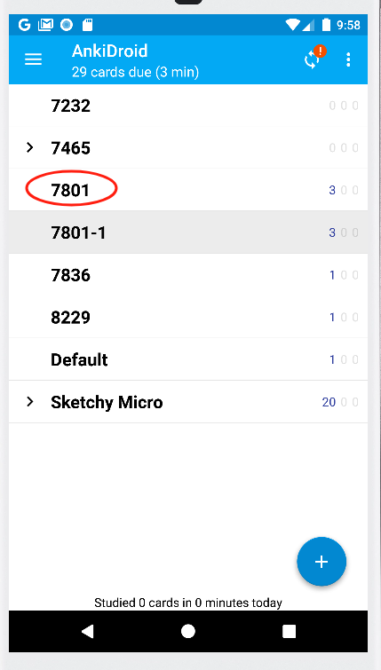

Long press and select 1 and 2

